A Multifactor Security Protocol for Wireless

Payment-Secure Web Authentication using Mobile

Devices

Dr.K V D Kiran  
Department Of CSE  
Koneru Lakshmaiah Education FoundationVaddeswaram, India [kiran_cse@kluniversity.in](mailto:kiran_cse@kluniversity.in)

Challa Venkata Pranith  
Department Of CSE  
Koneru Lakshmaiah Education FoundationVaddeswaram, India  
[pranithchalla@gmail.com](mailto:pranithchalla@gmail.com)

Valiveti Lohya Sujith  
Department Of CSE  
Koneru Lakshmaiah Education FoundationVaddeswaram, India  
[lohyasujith1520@gmail.com](mailto:lohyasujith1520@gmail.com)Kolli Sai Kiran   
Department Of CSE  
Koneru Lakshmaiah Education FoundationVaddeswaram, India  
[kollisaikiran007@gmail.com](mailto:kollisaikiran007@gmail.com)

Pulivarthi Goutham   
Department Of CSE  
Koneru Lakshmaiah Education FoundationVaddeswaram, India  
[170031068@kluniversity.in](mailto:kollisaikiran007@gmail.com)

*Abstract*— The Smart-Phones have reformed the way we live. Mobile phones and PDA's have to a great extent filled in ubiquity and therefore clients have begun web based banking, buying of web based items and other online administrations. Past web access verification frameworks have utilized either the Web or the remote Versatile channel autonomously to validate the personality of far off client. Getting to the present online administrations consistently requires a username and secret phrase to verify the client personality. This is a huge weakness since the secret word can be hacked by the man in the center assault and later utilized for making unlawful admittance to the client's record. We will likely make a validation framework that is both secure and profoundly usable dependent on multifaceted verification approach. It utilizes a novel way to deal with make a confirmation framework dependent on Spasms (Exchange Recognizable proof code) and SMS (Short Message Administration) to authorize an additional security level with the conventional Login/secret phrase framework.We have additionally utilized an encryption method which depend’s on symmetric key and an iterated block figure idea. This idea has been utilized to keep Spasms as mystery code on PDAs/PDAs and is likewise used to start secure web exchange utilizing mobile phones/PDAs. At last we expand the framework for two way validation which confirms the two players (client and e-specialist organization). A definite danger examination exhibits that the proposed framework is secure against different sorts of web assaults like phishing, man-in-the-center, infections and something similar like mentioned above…

*Keywords— TIC transaction identification code, Multifactor, Online transaction/payments, , Authentication,* *Customer Agent (CA),Customer Bank (CB),Customer Bank Authentication Server (CBAS), Merchant Bank (MB),Merchant Agent (MA).*

# Introduction

As registering gets unavoidable, individuals progressively depend their business over the Web by utilizing internet business. Presently, the Web is a favored source to get to online eservices, for example, internet business, e-casting a ballot, e-banking, e-government,& soon something similar to that… Online applications require a solid security highlight to ensure client classified information. Security is a significant issue in web based online installment framework. There are different web dangers which influence the security arrangement of web and increment hazard for electronic exchange. The greater part of the verification framework depends on passwords, individual distinguishing proof numbers and keys to get to their own record data This sort of verification framework can not check or confirm the character of the clients who the person in question claims to get to the present electronic administrations consistently requires a username and secret key to validate the client character. This is a huge weakness since the secret word can be hacked by the man in the center assault furthermore, later utilized for making illicit admittance to the client's record.

With regards to the correspondence of delicate information security has consistently been a significant subject. With equipment progresses permitting clients the upside of openness utilized in cell phones, individuals are currently investing increasingly more energy in these gadgets. Furthermore, with the viral popularity of web-based media applications and single sign-on, clients don't generally avoid potential risk varying with their data. Multifactor Authentication makes more and shifted dividers to shut out some unacceptable individuals from seeing your data

What is Single-factor Authentication (SFA):

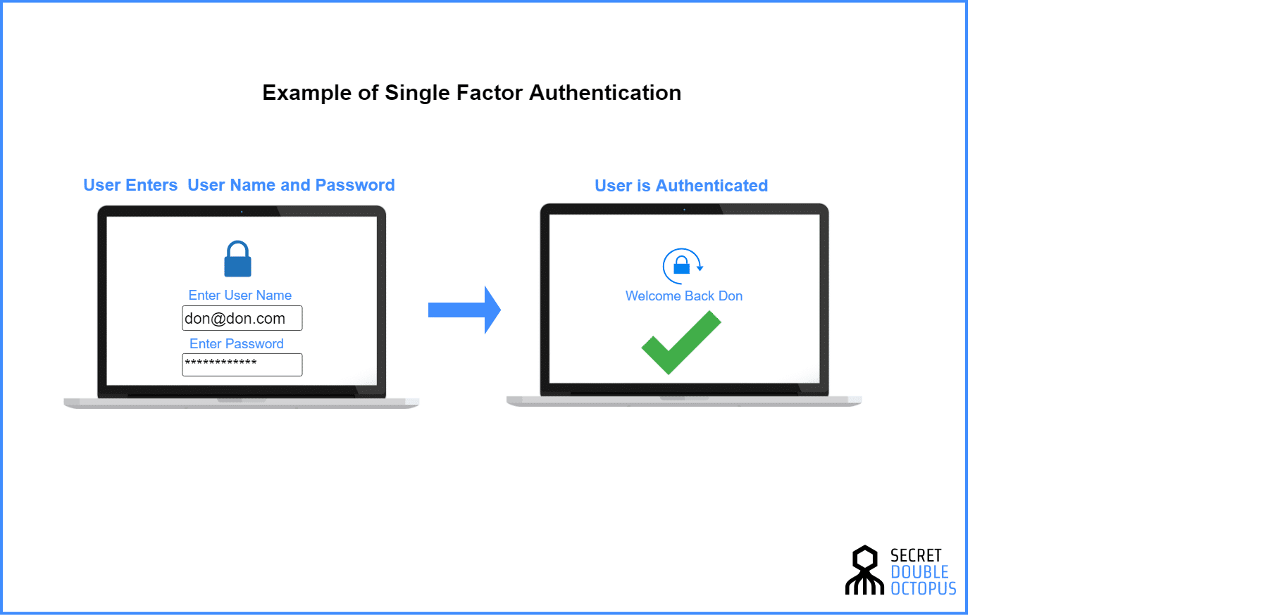

*Figure 1: Single-factor Authentication*

Single-factor authentication is the most straight-forward type of confirmation strategies. With SFA, an individual matches one credential to confirm himself or herself online. The most well known case of this would be a password to a username. Most verification today utilizes this kind of verification strategy.

What is Two-factor Authentication (2FA):

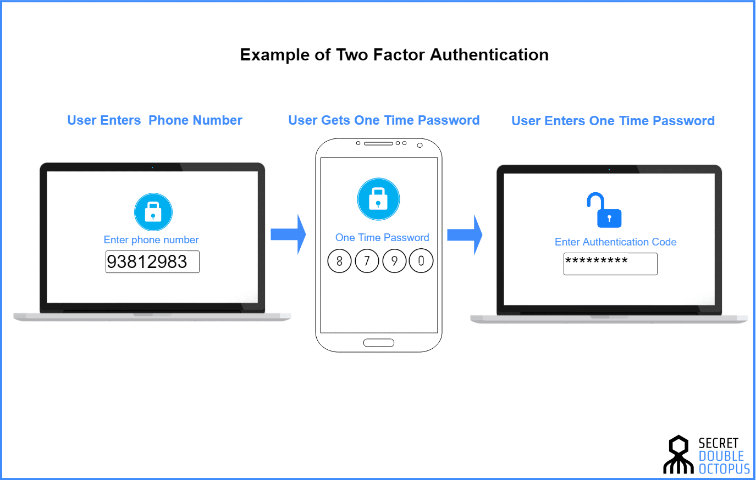

*Figure 2: Two-factor Authentication*

Two-factor authentication uses the same password/username combination, but with the addition of being asked to verify who a person is by using something only he or she owns, such as a mobile device.

Getting on the straight: it uses two factors to confirm an identity

What is Multi-factor Authentication (MFA):

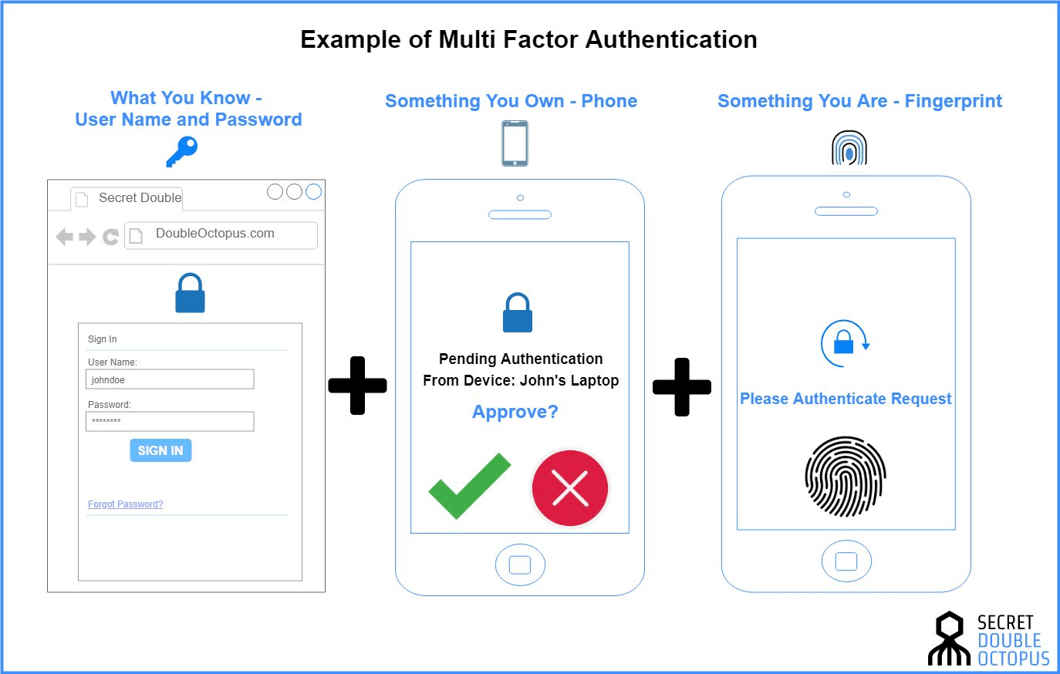

*Figure 3: Multi-factor Authentication*

Multi-factor Authentication uses a combination of the following factors: something you know, something you have and something you are. 2FA is a subset of MFA

# Literature survey

In recent years, the development in Information technology has unleashed new challenges and opportunities for new authentication systems and protocols. Authentication ensures that a user is who they claim to be. The trust of authenticity increases exponentially when more factors are involved in the verification process. When security infrastructure makes use of two or more distinct and different category of authentication mechanisms to increase the protection for valid authentication, It is referred to as Strong Authentication or Multifactor Authentication. Multifactor authentication uses combinations of "Something you know," "Something you have,", "Something you are" and “Somewhere you are”, “Someone you know”, to provide stronger remote authentication than traditional, unreliable single-factor username and password authentication. In this paper we are doing a survey on the different aspects of multifactor authentication, its need, its techniques and its impact. Multi-factor authentication methods are difficult to compromise than single-factor methods. for example, the use of a logon ID/password is single-factor authentication (i.e., something the user knows) whereas, an ATM transaction requires multifactor authentication: something the user possesses (i.e., the card) combined with something the user knows (i.e., PIN). “Out-of-band” controls for risk mitigation can also be included in multifactor authentication methodology

# Existing System

Mobile Payment (M-payment) is a wireless payment system that has raised the attention of researchers in the last few years. M-Commerce payment can be conducted in several ways and is based on “any–where, any-time” paradigm. M-payment is a critical component in M-commerce or E-commerce applications. According to the world wide forum, M-payment on a mobile device would be very popular and provide tremendous opportunities for M-commerce in the coming years.

Secure Wireless payment system has become an important research area in the last few years. There are various types of electronic payment solutions are available for internet based commerce. mobile payment means wireless based electronic payment for M-commerce to support point-of-sale/point-of-service (POS) , payment transactions using mobile devices such as cellular phones, smart phones and personal digital assistants (PDAs), or mobile terminals. In general, M-payment systems is widely used by merchant to make wireless based payment, content vendors, and information and service providers to process and support m-payment transactions based on wireless commerce applications. As discussed in, the existing m-payment systems can be classified into three major types

- Account-based payment systems,

- Mobile POS Payment system,

- E-wallets or E-cash.

Therefore inorder to enchance more and efficient security to the online payments we have proposed a new protocol in the multiple factor authentication

# Proposed System

## Multifactor Authentication:

Single-factor authentication is inadequate for high-risk transactions involving access to customer information or the movement of funds to other parties. To provide secure web transactions using cell phones multi factor authentication techniques have to be used. In our system we are using multi factor authentication using two different modes. The implementation is performed using TIC and SMS. While SMS has been used in previous approaches to the problem , we are introducing the new concept of TIC as a novel method of authenticating a transaction and the user.

TIC (Transaction Identification Code) Authentication is the technique which is used to identify both the user and the ongoing transaction. TIC code certifies that the current transaction has been initiated by the right person and it is a valid user who is trying to access his/her account

TIC codes are:

* Issued by the Bank or Financial institution to its customer.
* 8 bit or 16 bit Pseudo randomly generated code which is assigned to the customers.
* May be complicated digit sequence or combination of numeric or alpha numeric characters.
* One TIC code is used only once, i.e. a unique TIC is used for each transaction.

Here we are assuming financial institutions are responsible to store TIC generation logic and algorithm confidentially and they have their specific parameters to decide the complexity of TICs format. Financial institutions are also responsible for upgrading from time to time the TIC generation logic and data and also to keep it absolutely secret. The user will get the list of TIC codes from the bank or financial institution according to its requirement.

The Bank or Financial institution will keep a record of issued TIC codes to its customers and match the same code during the online web transaction. A TIC code is cancelled after each successful transaction.We can also decide a validity time period of TICs according to issuing organization policies, which provides an extra security feature in the system.

## Proposed Protocol:

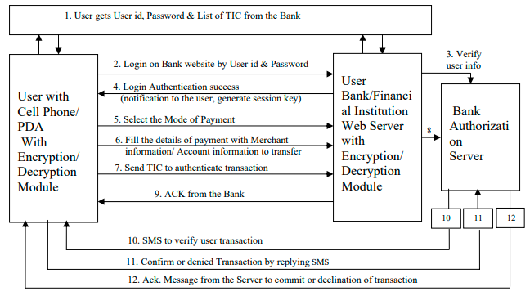

*Figure 1: Protocol for wireless payment: Multifactor secure Web authentication protocol using mobile devices*

*Steps of protocol flow:*

1. User gets username/password and Transaction Identification codes (TICs) from the Bank. Each user has only one username/password to their account, but TIC code is unique for each online transaction. So users will get list of TIC codes from the bank authority or authorized financial institution according to their requirement.
2. A Web-based username/password basic authentication is used to identify the user to the Web server.
3. The username and password will be verified by the Bank Authentication Server. After user recognition the user will get option screen to proceed further.
4. The user will get a notification of a successful logging with welcome message. This step also generates a session key.
5. The user will select mode of payment. We have considered two modes of payment: Credit Card based system & Account based Electronic transfer. It is straightforward to add other modes to our system.
6. User will insert the details of payment by filling in a simple form with details such as merchant’s bank and branch code information, invoice number and account number to which an amount has to be transferred.
7. The user will insert a TIC code by simply choosing a TIC code from the stored list of TICs. Note that TICs are stored, with password protection, with a local encryption on the cell phone. The user will decrypt and insert the TIC in the financial transaction to give unique authentication to each web transaction. All details of the transaction, with attached TIC, will be further encrypted by AES encryption technique and submitted to the bank web server. The bank web server would pass it on to the authentication server where it would be decrypted and matched with the list of TICs that have been issued to the user. Discussions on the encryption/decryption technique used in the proposed system .
8. The bank authorization server decrypts the received message and extracts the TIC. It then verifies the TIC received from the user by comparing it with the stored list of TICs in the user account information at server database. If both TICs match then it cancels the used TIC from its database and goes to the next step. If no TIC matched with those in database then the authentication server will deny the user transaction and display appropriate error message to the user.
9. Bank server generates an acknowledgement to the user, which makes user free to logout from the web portal and wait for a confirmation SMS or to initiate another financial web transaction.
10. After completing the database updation with respect to the ongoing transaction, the authentication server will send an SMS to the user’s cell phone to verify the initiated web transaction. The cell phone number of the user is available on authentication server.
11. The user would confirm their initiated transaction by choosing “YES” or deny it by choosing “NO” by replying confirmation SMS.
12. The server will notify the user by a Message to acknowledge the successful completion of transaction or declination of the transaction.

Therefore here the total flow of execution is segregated into 4 main parts as follows,

*Part 1: First Authentication of User to the Bank*

*Authentication Server*

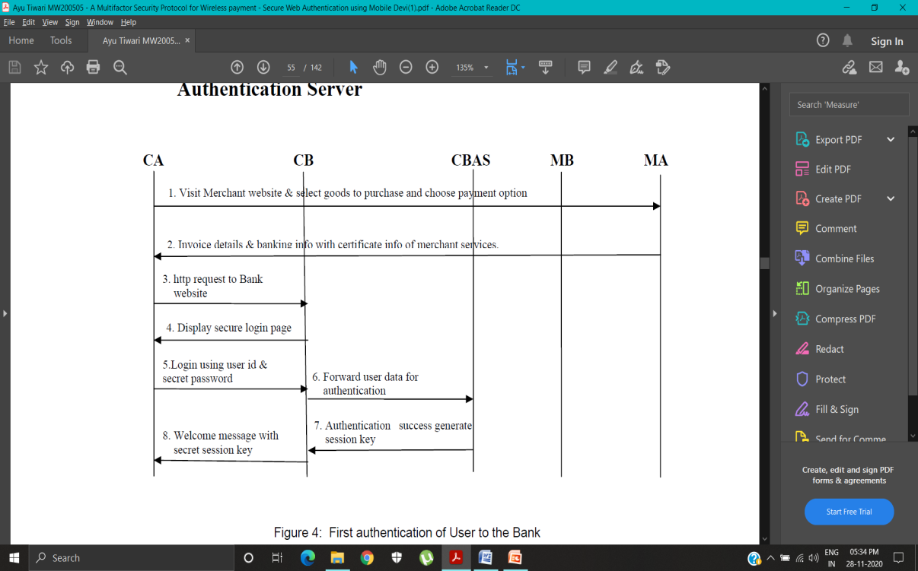

*Figure 2: First authentication of User to the Bank*

After successful completion of first authentication of the user by login , two way authentications take

place as mentioned in part- II.

*Part II: Two Way Authentication: Authentication of*

*Merchant to the Customer*

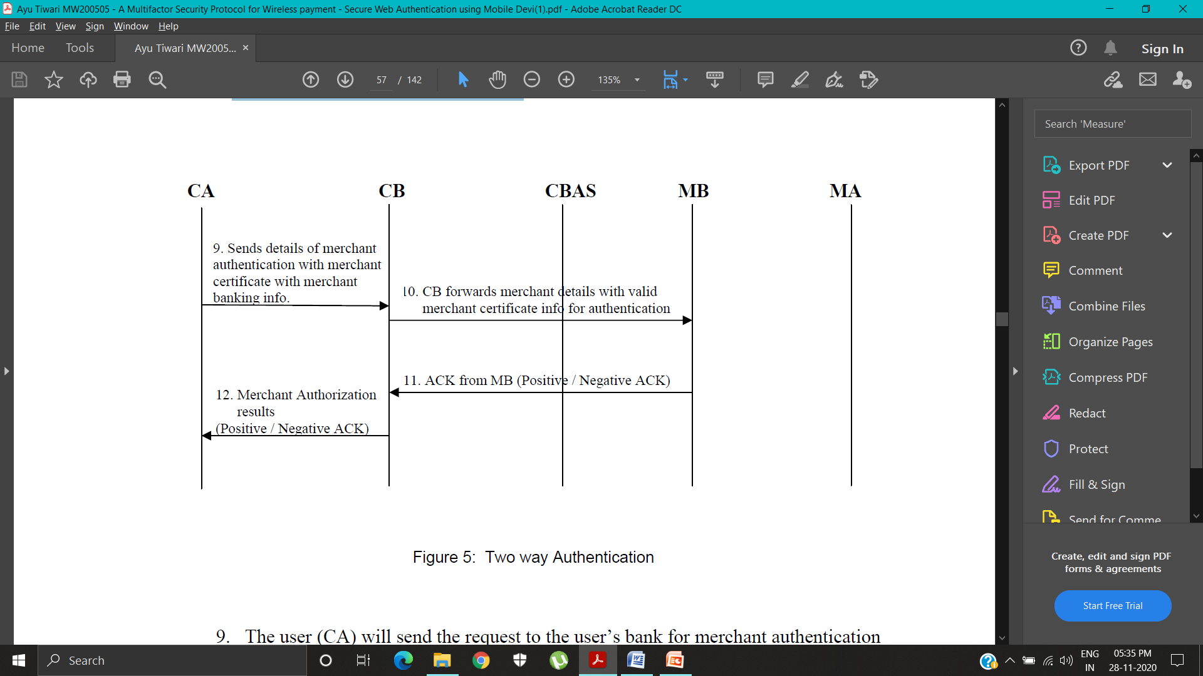

*Figure 3: Two way Authentication*

To make payment it will run multifactor secure web authentication protocol as mentioned in Figure 1 which continues in part-iii

*Part III: Second Authentication of User to the Bank*

*Authentication Server*

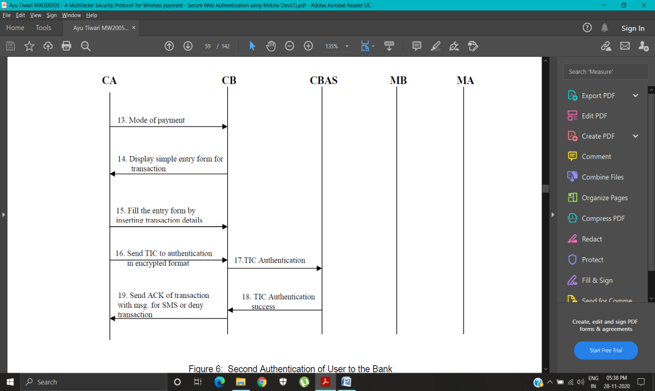

*Figure 4: Second Authentication of User to the Bank*

After successful match of the TIC the user is free to close the current user session or make new financial transaction. The next step is that the authentication server will generate a SMS destined to the user

*Part IV: Third Authentication of User by SMS*

*confirmation of Web Transaction to the Bank*

*Authentication Server*

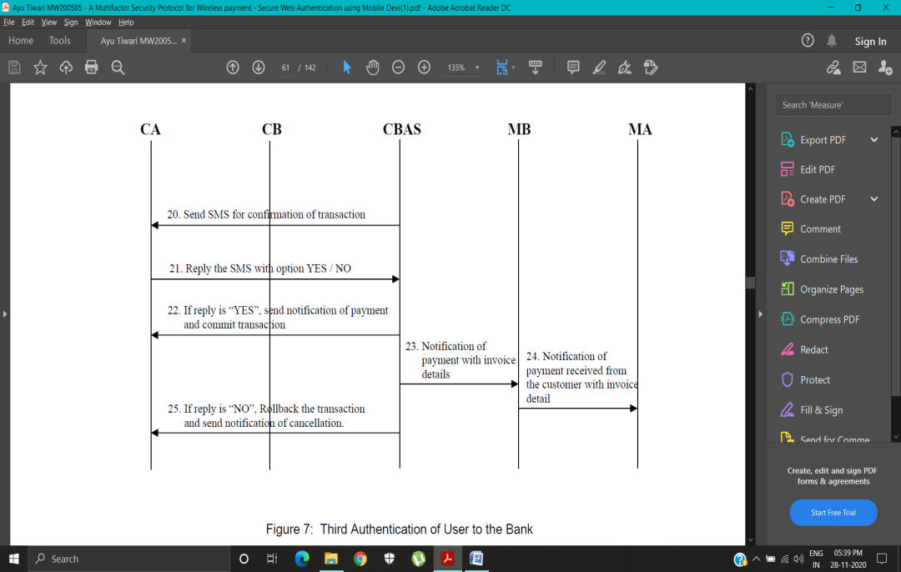

*Figure 5: Third Authentication of User to the Bank*

The complete transaction flow from client to server is strictly in an encrypted manner to maintain system security and protect confidential data of user.

# Security

Phishing fraud has become a popular technique for user identity theft. Phisher’s fraudulently capture the sensitive information of users such as passwords and credit card

details to gain unauthorized access to the user’s confidential financial data and perform illegal transfer of funds. Phishing is generally carried out using email or an instant message or via phone contact

The proposed protocol is secure against phishing attacks. A multifactor secure protocol for user authentication has the capability to secure the user data and maintain integrity, confidentiality and access control from malware access. To understand the origin of the security we consider various cases below.

*Case I: If phisher fraudulently acquires user id and secret password*

TIC codes are secret codes issued to valid account holders and TICs are not publicly accessible. It is a one time code for each online transaction and it is randomly generated in nature so a phisher can not guess the next TIC code of user account.

*Case II: Transmission of TICs over insecure channel*

TIC code transmission from the user’s cell phone / PDA to the web authentication server is in strongly encrypted format so phishing attackers cannot decrypt it easily to access user’s private information on server side. Moreover, one TIC is used only once and then discarded.

*Case III: If phisher fraudulently acquires user’s secret password and also one TIC code by some phishing attack*

The TIC codes are psuedo random in nature so if phishing attacker gets one TIC code sample by some phishing technique, the phisher can not generate next TIC code because TIC generation logic is strictly confidential at web authentication server and we have assumed that banks and financial institutions are responsible for time to time updation of TIC generation data and updation of TIC generation algorithms

# Conclusion

The current validation procedure for online installation of framework isn't make sure about to secure client from wholesale fraud, as a the outcome any aggressor gain the entrance on classified data of client like Mastercard number or record secret key and make illicit exchange of store which will be charged to the substantial client's record In the introduced convention we have zeroed in on an application-layer security answer for remote installation of framework to execute a start to finish verification and information privacy between remote customer and java based secure worker. The introduced work proposed another convention for web client validation dependent on multifaceted verification approach which is totally secure and simple to execute

##### References

1. Adi W., Mabrouk A., Al-Qayedi A., Zahro A. , “Combined Web/Mobile Authentication for Secure Web Access Control”, In Wireless communications andNetworking conference,IEEE Communications Society, Atlanta, GA USA,volume 2, pp. 677- 681, March 2004.
2. J. Gao, J. Cai, K. Patel, and S. Shim , “Wireless Payment”, In Proceedings of the Second International Conference on Embedded Software and Systems (ICESS’05),Xian, China, pp. 367-374, December 2005.
3. S. Kungpisdan, B. Srinivasan and P.D. Le, “A Secure Account-Based Mobile Payment Protocol”, In Proceedings of the International Conference on InformationTechnology: Coding and Computing, IEEE CS press, Las Vegas USA, volume 1,pp. 35-39, April 2004.
4. Y.B. Lin, M.F. Chang, H. C.H. Rao, “Mobile Prepaid Phone Services”, In IEEE Personal Communications, volume 7 Issue 3, pp. 6-14, June 2000.
5. A. Fourati, H.K.B. Ayed, F. Kamoun, A. Benzekri, “A SET Based Approach to Secure the Payment”, In Mobile Commerce, Proceedings of 27th Annual IEEEConference on Local Computer Networks, Tampa, Florida, pp. 136 – 140,November 2002.
6. Huang Z., Chen K., “Electronic Payment in Mobile Environment”, In Proceedings of 13th International Workshop on Database and Expert Systems Applications (DEXA'02),University of Marseille, France, pp. 413 – 417, September 2002.
7. V. Pasupathinathan, J. Pieprzyk, H. Wang and J.Y. Cho, “Formal Analysis of Cardbased Payment Systems in Mobile devices” , In Fourth Australasian Information Security Workshop, Hobart, Australia, Conferences in Research and Practice in Information Technology, Volume 54, pp. 213-220, January 2006.
8. J. Hall, S. Kilbank, M. Barbeau, E. Kranakis, “WPP: A Secure Payment Protocol for Supporting Credit- and Debit-Card Transactions over Wireless Networks”, In IEEE International Conference on Telecommunications (ICT), Bucharest,Romania , volume 1, June 2001.
9. Halevi Shai, Krawczyk Hugo**,** “ Public-key cryptography and password protocols”, In Proceedings of the 5th ACM conference on Computer and communications security, San Francisco, Volume 2 Issue 3, pp. 230 – 268, November 1998.
10. L. Albert, K. C. Kaya, “CONSEPP: CONvenient and Secure Electronic Payment Protocol Based on X9.59”, In 17th Annual Computer Security Applications Conference, New Orleans, Louisiana, IEEE press, pp. 286-295, December 2001.
11. Soriano M. and Ponce D., “A Security and Usability Proposal for Mobile Electronic Commerce”, In IEEE Communication Magazines”, Volume 40, Issue 8,pp. 62- 67, August 2002.
12. Itani Wassim and Kayssi Ayman I., “J2ME End-to-End Security for MCommerce”, In Journal of Network and Computer Applications, Elsevier Ltd, Volume 27 Issue 1, pp. 13-32, January 2004.
13. Jablon David P., Integrity, Sciences, Inc. Westboro, MA, ACM SIGCOMM, “Strong Password - Only Authenticated Key exchange”, Computer Communication Review, Vol. 26, pp. 5 – 26, September 2005.
14. M. Debbabi, M. Saleh, C. Talhi and S. Zhioua, “ Security Evaluation of J2ME CLDC Embedded Java Platform “, In Journal of Object Technology, volume.5, Issue 2, pages 125–154, March–April 2006. ([http://www.jot.fm/issues/issues 2006 3/article2](http://www.jot.fm/issues/issues%202006%203/article2))
15. Lawton G., “Moving Java into Mobile Phones”, IEEE Computer, Volume 35 Issue 6, pp. 17- 20, June 2002.
16. J. Kelsey, B. Schneier, and N. Ferguson, “Yarrow-160: Notes on the Design and Analysis of the Yarrow Cryptographic Pseudorandom Number Generator”, In Sixth Annual Workshop on Selected Areas in Cryptography, Kingston, Ontario,Canada, Springer Verlag, August 1999.
17. Jerry Gao, Krishnaveni Edunuru, Jacky Cai, and Simon Shim, “P2P-Paid: A Peer-to- Peer Wireless Payment System”, In Proceedings of the Second IEEE International Workshop on Mobile Commerce and Services (WMCS’05), Munich, Germany, pp. 102-111, July 2005.
18. Ayu Tiwari, Sudip Sanyal, Ajith Abraham, Sugata Sanyal and Svein Knapskog, ”A Multifactor Security Protocol For Wireless Payment-Secure Web Authentication using Mobile Devices”, IADIS International Conference, Applied Computing 2007, Salamanca, Spain, pp. 160-167, February 2007.
19. Adi W., Mabrouk A., Al-Qayedi A., Zahro A. , “Combined Web/Mobile Authentication for Secure Web Access Control”, In Wireless communications and Networking conference, IEEE Communications Society, Atlanta, GA USA, volume 2, pp. 677- 681, March 2004.
20. [https://www.cmu.edu/iso/news/mfa-article.html#:~:text=Multi%2Dfactor%20authentication%20should%20be,protect%20highly%20sensitive%20personal%20information](https://ieeexplore.ieee.org/document/8356384)